**WCF Http Server**

This project:

<https://github.com/EliArad/WCFHttpServer>

Show how to create WCF Http server that is wrap by a console app and windows service.

There is a small WCFConnect class that is shared to the application and the windows service in order to connect to the WCF service.

The solution has 4 projects

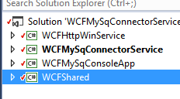

* The WCF service - WCFMySqlConnectorService
* The console app that run the wcf service
* Windows service
* WCFShared class that both application and windows service are using to start and stop the WCF server

The WCF service support cross origin domain

CorsConstants

Which let you run access the server from two different ip address.

The code is very much self-explanatory and to use it we can create a windows app that send rest command to the server.

The server can create users and list users from data base.

If you need more information contact me at [easp13@gmail.com](mailto:easp13@gmail.com)